MEASUREMENTS & INSTRUMENTATION

Academic Year : | 2018-2019 | Question Bank | Programme: | B.E – ECE
Year / Semester : | II / IV |  | Course Coordinator:

PART – A ( 2 Mark Questions With Key)
S.No | Questions |  |  | Mark |  | COs |  | BTL
1 | Define instrument? | 2 |  |  |  | 3 |  | K1
 | An instrument is a device for determining the value or magnitude of a quantity.
2 | Write the dynamic characteristics of any measurement system. |  |  | 2 |  | 3 |  | K1
a. Step change
b. Linear change
c. Sinusoidal change
d. Lag
e. Fidelity
f. Dynamic error

3 | What is standard? What are the different types of standards? |  |  | 2 |  | 3 |  | K1
A standard is a physical representation of a unit of measurement. A known accurate measure of physical quantity is termed as standard.
Types:
a.Primary standard
b. Secondary standard
c. International standard
d. Working standard.
4 | What is calibration? |  |  | 2 |  | 3 |  | K1
 | Calibration is the process of checking the accuracy of instrument by comparing the instrument reading with a standard meter of known accuracy.
5 | Define the terms precision and sensitivity. ? |  |  | 2 |  | 2 |  | K1
Precision:
It is a measure of the repeatability of a series of measurements.
Sensitivity:
It is the measure of change in reading of an instrument for a given change in the measured quantity.
6 | Define arithmetic mean ? |  | 2 |  | 3 |  | K1
 | Arithmetic mean is calculated by taking the sum of all readings divided by the number of readings.
7 | Define static error ? |  | 2 |  | 2 |  | K1
 | The static error of a measuring instrument is the numerical difference between the true value of a quantity and its value as obtained by measurement.
8 | What are the different calibration methodologies? |  | 2 |  | 2 |  | K1
(i) Direct calibration:
a. Meter calibration
b. Generator calibration
C. Transducer calibration
(ii) Indirect calibration:
a. Meter calibration
b. Generator calibration
c. Transducer calibration
9 | What are the basic elements of a measurement system? |  | 2 |  | 2 |  | K1
a. Primary sensing element.
b. Variable conversion element.
c. Variable manipulation element.
d. Data transmission element.
e. Data presentation element.
10 | Define environmental error. |  | 2 |  | 2 |  | K1
 | This error occurs due to external conditions to the measuring device, including conditions in the area surrounding the instrument, such as the effects of change in temperature, humidity, magnetic or electrostatic fields.
11. | Give the applications of measurement systems. |  | 2 |  | 2 |  | K1
a. The instruments and measurement systems are sued for
b. Monitoring of processes and operations.
c. Control of processes and operations.
d. Experimental engineering analysis.
12. | Name the different essential torques in indicating instruments. |  | 2 |  | 2 |  | K1
a.Deflecting torque
b.Controlling torque
c.Damping torque
13. | List the different types of possible errors in measurements. |  | 2 |  | 2 |  | K1
a. Gross error
b. Systematic error
c. Environmental error
d. Observational error
e. Random error
14. | Define indicating instruments |  | 2 |  | 2 |  | K1
 | Indicating instruments are used to indicating the magnitude of unknown quantity. The examples are ammeters, voltmeters etc.
15. | Define recording instruments. |  | 2 |  | 3 |  | K1
 | These instruments give a continuous record of the given input quantity. The examples are various types of recorders.
PART – B (12 Mark Questions with Key)
S.No | Questions |  |  | Mark |  | COs |  | BTL
1 | Describe the functional elements of an instrument with its block diagram. |  |  | 12 |  | 1 |  | K2
1.Functional elements of an instruments:( Diagram)

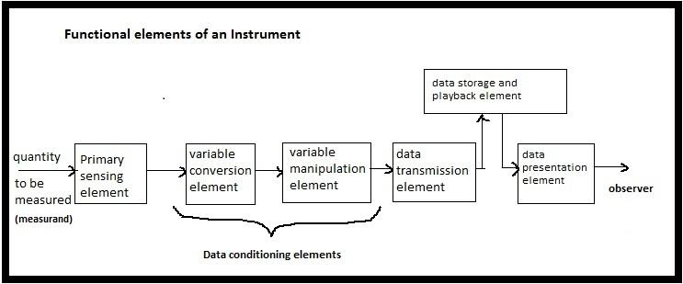

2. Functional elements of an instruments:( with Description)
1.Primary sensing element
2.Variable conversion element
3.Variable manipulation element
4.Data transmission element
5.Dara storage and play back element
6. Data presentation element
2 | Discuss in detail various types of errors associated in measurement and how these errors can be minimized. |  |  | 12 |  | 1 |  | K2
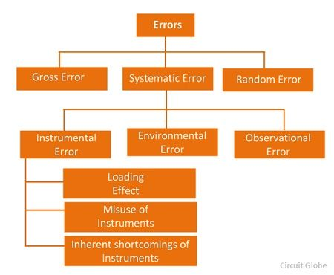
1.Types of errors:(with description)

3 | Discuss in detail the various static and dynamic characteristics of measuring system. |  |  | 12 |  | 1 |  | K2
Static characteristics with description

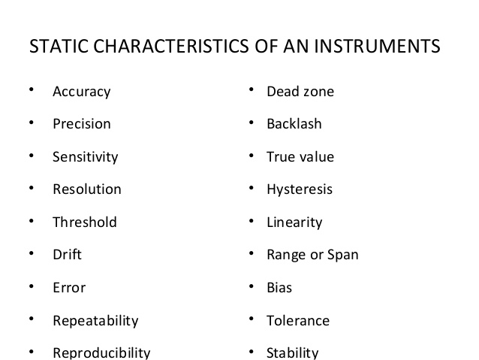

Dynamiccharacteristics with description :

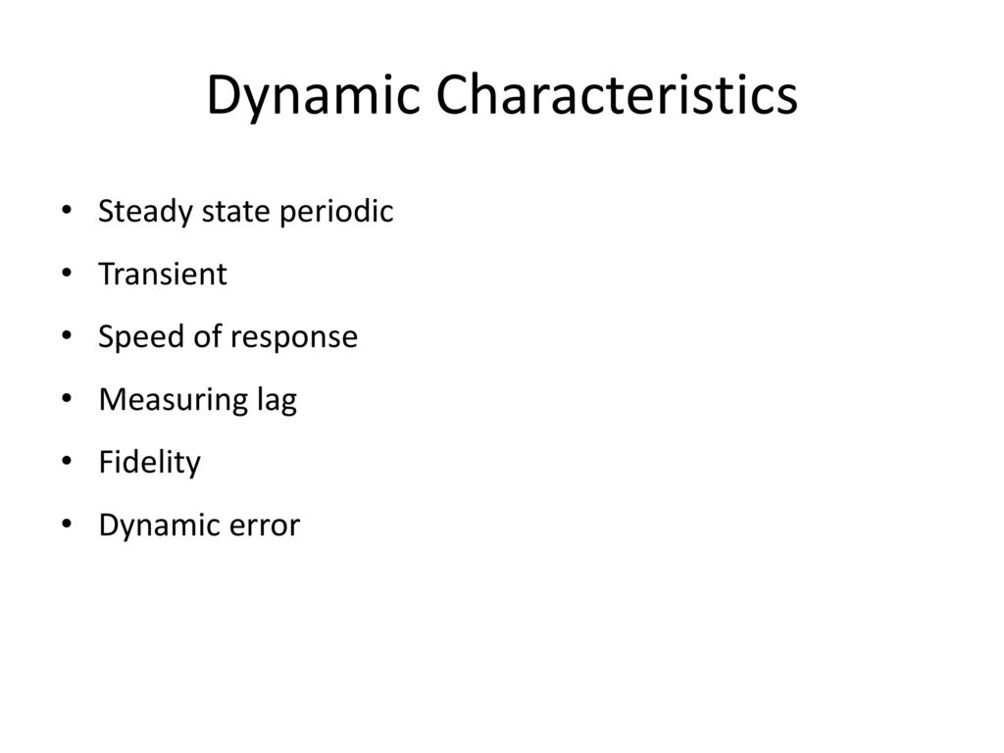

4 | What are the different calibration methodologies? Explain. |  |  | 12 |  | 1 |  | K2
Types of calibration : (Diagram with descriptions)

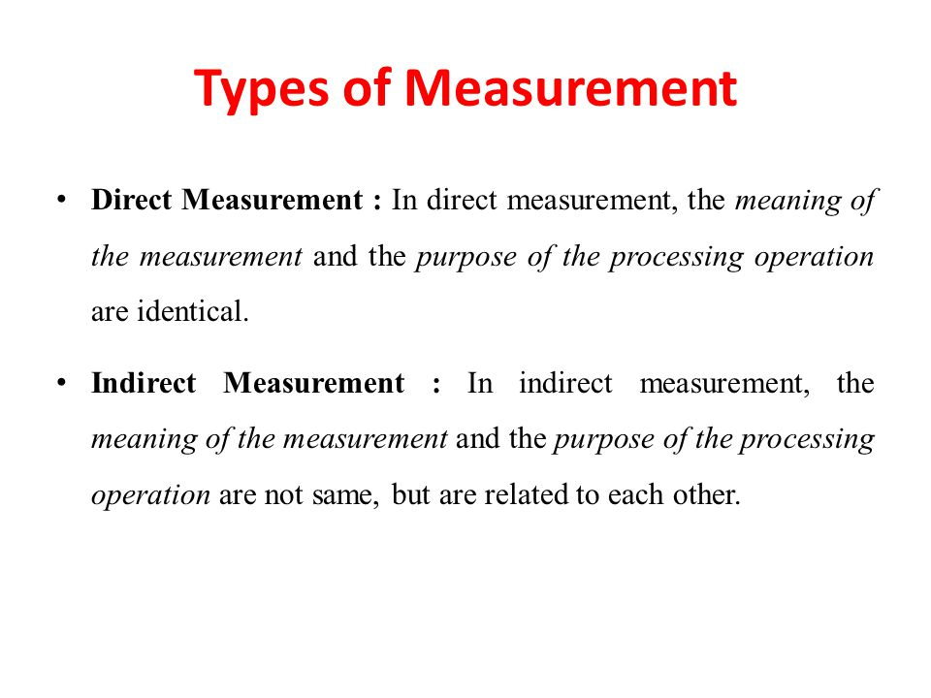
Comparison of calibration :

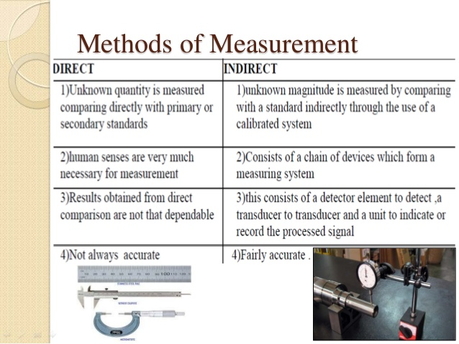

5 | The expected value of the voltage to be measured is 150 V. However, the measurement gives a value of 149 V. Calculate (i) obsolute error; (ii) percentage error; (iii) relative accuracy; (iv) percentage accuracy and (v) error expressed as percentage of full scale reading, if the scale range is 0-200v. |  |  | 12 |  | 1 |  | K2
Find the following values:

1.Absolute error = + 1 v

2. Percentage error = 0.66%

3. Relative accuracy = 0.9933

4. percentage accuracy = 99.33%
5. percentage of full scale reading = 0.5%
6 | What is standard? Explain the different types of standards? |  |  | 12 |  | 1 |  | K2
1. Different types of standard:(with description)

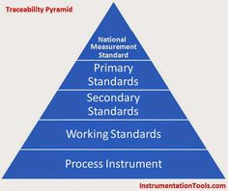

1.International standards
2.Primary standards
3. Secondary standards
4.Working standard

PART – C (20 Mark Questions with Key)
S.No | Questions |  |  | Mark |  | COs |  | BTL
UNIT: 1
1 | In a survey of 15 owners of a certain model of car, the following figures are for average petrol consumption were reported.  25.5, 30.3, 31.1, 29.6, 32.4, 39.4, 28.9, 30.0, 33.3, 31.4, 29.5, 30.5, 31.7, 33.0, 29.2 calculate mean value, median value, standard deviation and the variance. |  |  | 20 |  | 2 |  | K3
Find the values of:

1.Mean value = 31.0533

2.Median value = 30.5

3.Standard deviation= 3.00

4.Variance = 9.00

2 | The set of independent measurement of voltages are recorded as 101.2, 101.4, 101.7, 101.3, 101. 3, 101.2, 101 .0, 10 1. 3, 101.5, and 101.1 calculate i) Arithmetic mean ii) Deviation from mean iii) Standard deviation and iv) probable error. |  |  | 20 |  | 2 |  | K3
1.Arithmatic mean = 101.3

2. Deviation from mean :0.14

3. Standard deviation= 0.2 v

4. Probable error of one reading = 0.0449

